Town of Sudlersville

200 S. Church Street
PO Box 116
Sudlersville, MD 21668
410-438-3465
Fax-410-438-3376
Email: townoffice@townofsudlersville.org

ELECTED AND APPOINTED OFFICIALS OF SUDLERSVILLE

Town Manager: Virginia Albers
Town Commissioners: Keith Griffith- President
Kevin Kerr
Larry Leonard
Laura McMullen
John Haag
Planning Committee: Reese Coleman-President
E.T. Kimble-Assistant Chair
Faye Williams
Andrea Haag

Commissioners Meeting: the first Wednesday of every month at 6:30 PM
Planning Commission Meeting: Third Thursday of every month at 7:00 PM, As needed basis the First Thursday of Every month at 7:00 PM

Town History
he community that was to become Sudlersville took root in 1740 when Joseph Sudler, a Kent Island landowner, purchased 800 acres south of the Chester River. The land included the homestead known as Sledmore, which had been built in 1713. Most likely, his son Richard was the first Sudler to live there; he died in 1797 and was buried in the family graveyard. Since that time until the present day, a continuity of direct descendants of the Sudler family has lived at Sledmore and elsewhere in Sudlersville.
In 1811, Dixon's Tavern and a post office were established near Sledmore in the village called Sudler's Cross Roads. That name was changed to Sudlersville in 1839. By the mid-1800s, the village had 15 houses, a general store, a Methodist Church, and a blacksmith. At the end of the century, there were about 40 houses and an assortment of commercial, ecclesiastical, and educational institutions. One of those was the Asbury Methodist Episcopal Church, which now houses the Sudlersville Memorial Library.

The historic Sudlersville Train Station was purchased in 1987 and restored by the Sudlersville Community Betterment Club (SCBC). This Club was established in 1916 by members of the Town of Sudlersville, Maryland, who were interested in preserving the heritage of the Town and sought to improve the quality of life for its citizens. Today, the station is a museum displaying artifacts of the Town of Sudlersville and surrounding area, railroad history and memorabilia of a notable former resident, National Baseball Hall of Fame's, Jimmie Foxx. The Train Station is located at 101 S. Lind

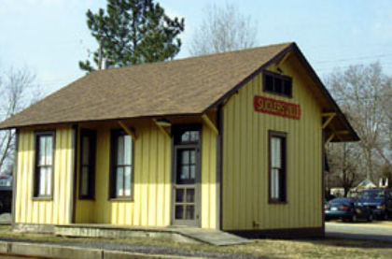
Sudlersville Community Betterment Club

Was established in 1916 by members of the town of Sudlersville Who were interested in preserving the Heritage of the Town
Today We own and maintain the
Jimmie Foxx Statue Lot and the Sudlersville Train Station Museum
We hold several events throughout the year
If interested in becoming a member and Preserving History
Email us at sudlersvillemuseum@gmail.com
Or you can call
Sharon Andrews
410 -703-9212

Sudlersvillemusuem.org
Local Business
E.T. Kimble & Co
125 Miller Street
Sudlersville, MD 21668
410-428-3838

Carletto Pizza & Pasta
220 N. Church Street
Sudlersville, MD 21668
410-438-3003

Brusca Nursery
140 Brusca Lane
Sudlersville, MD 21668
410-438-3180
bruscanursery.com
Lena’s Bar & Grill
5124 Sudlersville Road
Sudlersville, MD 21668
410-438-3033
NAPA Auto Parts
211 E. Main Street
Sudlersville, MD 21668
410-438-3186
Godfreys Farm
302 Leager Road
Sudlersville, MD 21668
410-438-3509
Godfreysfarm.com
Phillips Garage
119 E. Main Street
Sudlersville, MD 21668
410-438-3183
Phillipsgarageinc.com
Patriot Acres Farm Brewery
1621 Millington Road
Sudlersville, MD 21668
410-708-5424
Patriotacresfarmbrewery.com
Parkside Grocery & Deli
208 E. Main Street
Sudlersville, MD 21668
410-438-2500

Sudlersville Storage
211 E. Main Street
Sudlersville, MD 21668
410-438-6007

Roseland Nurseries
140 Rosebud Lane
Sudlersville, MD 21668
410-755-6500
Roselandnurseries.com
Sudlersville Meat Locker
204 E. Main Street
Sudlersville, MD 21668
410-438-3106
Sudlervillemeats.com

Sudlersville Community Laundromat
201 N. Charles Street
Sudlersville, MD 21668
www.facebook.com/Sudlersville-Community-Laundromat-452565498902963

Leager Construction
621 Millington Rd
Sudlersville, MD 21668
410-758-4080
People’s Bank
228 E. Main Street
Sudlersville, MD 21668
410-438-3100
A. Cannon & Sons Cabinet & Millworking
209 N. Church Street
Sudlersville, MD 21668
410-438-3514

Sudlersville Volunteer Fire Co.
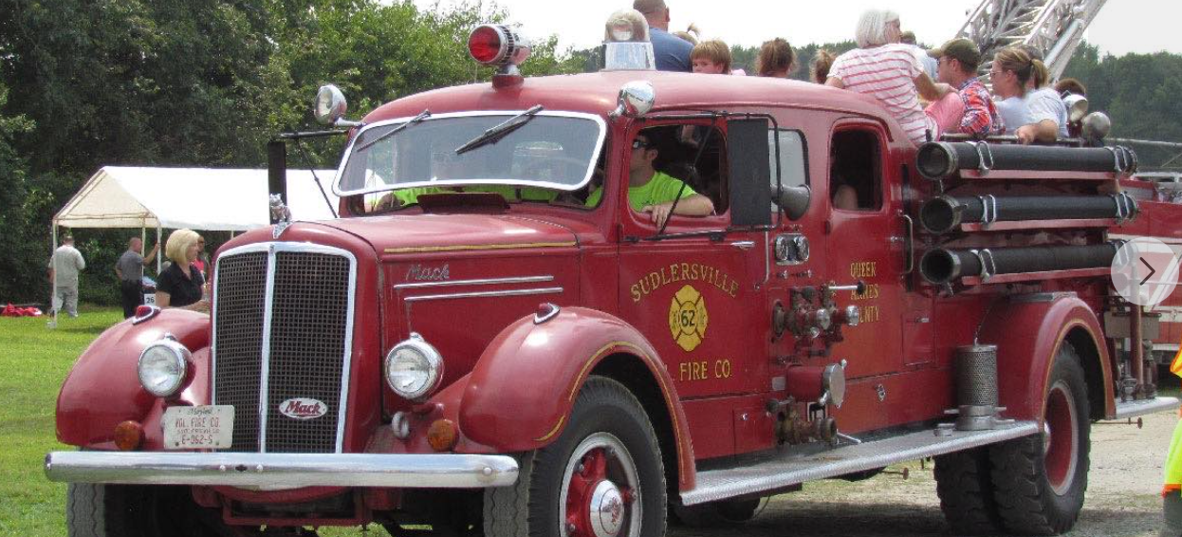

203 N. Church Street
PO Box 61
Sudlersville, MD 21668
svfc6.com

Local Churches
Faith Bible Church
407 Dudley’s Corner Road
Sudlersville, MD 21668
410-438-6003
Faithbiblechurch316.com
Sudlersville United Methodist Church
105 N. Church Street
PO Box 202
Sudlersville, MD 21668
410-438-3816
Sudlersvilleumc.org

Saint Andrews Episcopal Church

Local Providers
Delmarva Power
PO Box 17006
Wilmington, DE 19850
Delmarvapower.com
1-800-375-7117

Breezeline (tv, phone, internet)
1-888-9600
https://business.breezeline.com
Choptank Electric
1-877-892-0001
Choptankelectric.coop

Senior Centers and Living Facilities

Sudlersville Senior Center
605 Foxxtown Drive
Sudlersville, MD 21668
410-438-3159
Dogwood Village
109 Charles Street
Sudlersville, MD 21668
410-438-3549
Foxxtown Apartments
410-758-8634
qacha.org/foxxtown

